**Installation Steps**

* Step 1 🡪 Python 3.7 installation 🡪 3.7.6- python-amd64 🡪 Customize

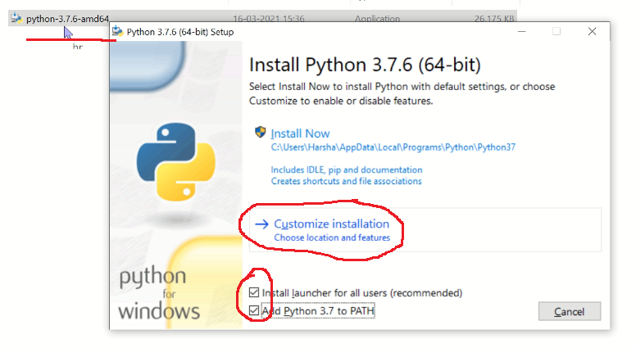

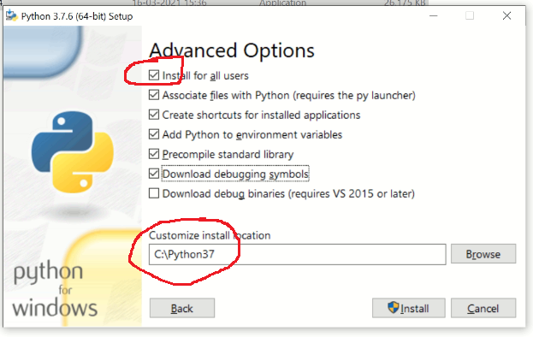

* Python 3.7.6 installation completed. Open Idle and check.
* Step 2 🡪 open idle, check all required installation working correctly or not
* 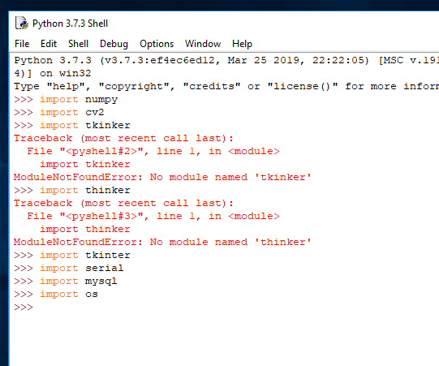

Step 3 🡪 C:\Python37\Scripts>pip install pandas

* pip install pandas
* pip install matplotlib
* pip install seaborn
* pip install scikit-learn
* pip install opencv-python

